Part 4 (20 marks = 10% of paper)

Answer the following extended answer question in blue or black ball point or ink pen. Where applicable use equations, diagrams and illustrative examples of the chemistry you are describing.

Marks are awarded for the relevant chemical content of your answer, and also for coherence and clarity of expression. Your answer should be presented in about 1½ – 2 pages. Begin your essay on the lined page following the end of the question.

As part of the Western Australian Government’s commitment to working towards sustainable transport energy solutions, it began one of the first major trials of hydrogen fuel cell buses in the world in 2004. Three Daimier Chrysler hydrogen fuel cell buses will be trialed for two years on normal Perth service routes.

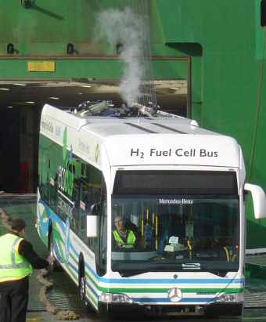
The photograph depicts the first bus being unloaded from the ship, with the pure steam rising from its exhaust pipe visible at the rear.

These fuel cell buses run wholly on hydrogen gas. Although it is the most abundant element in the universe, hydrogen is not found in pure form on earth and must be produced or reformed from a source. Steam reforming of natural gas is currently the most widely used and economical method of producing hydrogen.
BP is constructing a Hydrogen re-fuelling station for the purposes of the trial. The buses will be housed, re-fuelled and maintained by PATH Transit.
The hydrogen for the fuel cell bus trial will be produced by BP as a by-product from their oil refinery in Kwinana and piped to the BOC site next door where it will be purified and pressurised. The compressed hydrogen will then be trucked to the bus depot and off-loaded to the re-fuelling facility, from which the hydrogen fuel cell buses will be re-fuelled.

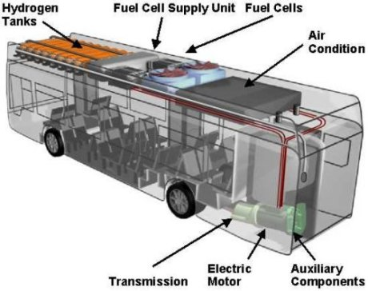
Bus specifications
Passenger capacity: 60-70 people
Net power of the fuel cell unit: >250 kW
Range: 200-300 km
Length: 12m
Weight: 5 tonnes
Maximum weight of hydrogen: 44kg (1890 litres).
Hydrogen purity: 99.999%

Mercedes-Benz Citaro fuel cell bus.

The hydrogen fuel cell is a very efficient producer of electricity. It is claimed to be two to three times more efficient in converting fuel to electricity than an internal combustion engine.

From your understanding of electrochemistry as it applies to the fuel cell, discuss the power source of these buses and the likely outcome of this trial. Consider this in terms of any benefits or disadvantages a fuel cell energy source might have in contrast to the current combustion engine rather than addressing any politics of the day.

You are not expected to discuss details of the combustion engine in your answer. Rather, focus on the workings of the fuel cell. In your answer address aspects such as how the fuel cell produces electricity, providing the reactants needed, safety, impact on the environment and cost.

Source: http://www.dpi.wa.gov.au/fuelcells/.html

